November 25, 2020
Ref: IIH/MD/2020/11/009
His Excellency,
The Executive Governor of Kwara State,
Government House,
Ahmadu Bello Way,
GRA, Ilorin, Kwara State.
Your Excellency Sir,
ILORIN INNOVATION HUB ACTIVITY PLAN
As the year 2020 is coming to an end, I would like to convey our tentative plan of activities to wind down this year and prepare for next year subject to your approval. This is in line with the previous plans put in place for the Ilorin Innovation Hub and also to ensure that activities can start before the completion of the construction of the Ilorin Innovation Hub complex.
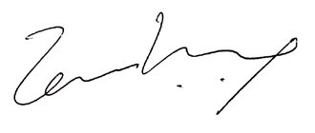

Temi Kolawole
MD Ilorin Innovation Hub

